IT204:Driver Drowsiness Detection System

Kumsetty Nikhil Venkat
Information Technology Department
National Institute of Technology Karnataka
(Deemed)
Surathkal, India
nikhilvenkat26@gmail.com
Ankit Gupta
Information Technology Department
National Institute of Technology Karnataka
(Deemed)
Surathkal, India
ankitgupta6252@gmail.com
Ayush Rahandale
Information Technology Department
National Institute of Technology Karnataka
(Deemed)
Surathkal, India
ayush22081993@gmail.com

Abstract— Driver Drowsiness System intermediate-level Python project, we will be making a drowsiness detecting device. A countless number of people drive on the highway day and night. Taxi drivers, bus drivers, truck drivers and people traveling long-distance suffer from lack of sleep. Due to which it becomes very dangerous to drive when feeling sleepy. The majority of accidents happen due to the drowsiness of the driver. So, to prevent these accidents we will build a system using Python, OpenCV and Arduino which will alert the driver when he feels sleepy.
Drowsiness detection is a safety technology that can prevent accidents that are caused by drivers who fell asleep while driving. The objective of this intermediate Python project is to build a drowsiness detection system that will detect that a person’s eyes are closed for a few seconds. This system will alert the driver when drowsiness is detected.
Keywords—Driver Drowsiness Detection System, OpenCV, Arduino.

Introduction

Drowsiness is the state of feeling tired or sleepy. We all can be a victim of drowsiness while driving, due to too many short night sleeps, tired physical condition or during long journeys. Driver fatigue affects the driving ability of many drivers in the following 3 ways:
1) It impairs coordination,
2) It causes longer reaction times and delays the reflex action of our central nervous system.
3) It impairs judgment .
The number of accidents as a result of drowsiness is increasing day by day. Recent statistics estimate that annually 76,000 injuries and 1200 deaths can be attributed to drowsiness related crashes. The advancement of technology in detecting the drowsiness of the driver is a noteworthy challenge as it can help reduce the probability of accidents taking place resulting in decrease in the death and injuries caused due to drowsy driving. Considering the hazards, drowsiness presents on the road, it is necessary to develop and efficient system which can work under low light environment and with better and faster speed. Nowadays the driver safety in the car is one of the most wanted system to avoid accidents.
Our objective of the project is to ensure the safety system. In this manner, a system which can keep a check of driver’s condition for drowsiness and alert the driver before it’s too late. For this we need a system which will focus on the open or closed state of driver’s eyes as by monitoring the state of the eyes detection of drowsiness is easy. Detection in real-time is the major challenge in the field of accident prevention system. The purpose of this study is to provide a real-time monitoring system using video processing, face/eye detection techniques. This system deals with automatic driver drowsiness detection based on visual information. Our system will capture the video through camera and after processing, it will alert the driver based on the results. This system has overcome few of the limitations of the existing systems. Our System will not only alert the driver but also the co-passengers with a loud alarm and the vehicles behind with an alert message with the help of a LCD display attached to the back of the vehicle to slow down or stop.

LITERATURE SURVEY

Some efforts have been reported in the development of the system to detect the drowsiness based on various factors like recording of head movements, heart rate variability, grip quality and movement of the steering wheel against the path markings on the road [3]. A drowsy driver detection system has been developed to concentrate the eyes of driver and check the drowsiness. Drowsiness detection techniques, in accordance with the parameters used for detection is divided into two sections i.e. intrusive method and a non-intrusive method. The main difference of these two methods is that the intrusive method, an instrument connected to the driver and then the value of the instrument is recorded and checked. But intrusive approach has high accuracy, which is proportional to driver discomfort, so this method is rarely used. [2]. The system has the capacity to choose whether the driver's eyes are opened or closed. At the point when the eyes are close for a really long time, a warning sign is issued to driver [3]. Explore a driver drowsiness monitoring and early warning system, which uses machine learning techniques, based on vehicle telemetry data. The proposed system can ensure safe driving by real time monitoring of driving pattern [4]. A solution for driver monitoring and event detection based on 3-D information from a range camera is presented. The system combines 2-D and 3-D techniques to provide head pose estimation and regions-of interest identification.

PROBLEM STATEMENT
Driver sleepiness detection using Python
Develop driver alert system, which gives an alert by watching drivers eye while driving a vehicle and alerting the vehicles following behind the

A. Objectives
- Input video stream for faces
- Apply facial landmark detection and extract the eye regions
- Compute eye aspect ratio to determine if the eyes are closed. If the eyes have been closed for a sufficiently long enough amount of time, sound an alarm to wake up the driver.
- Using Arduino Uno board to display alert message on the LCD screen to warn the following drivers to slow down or stop their vehicle.

IV. METHODOLOGY

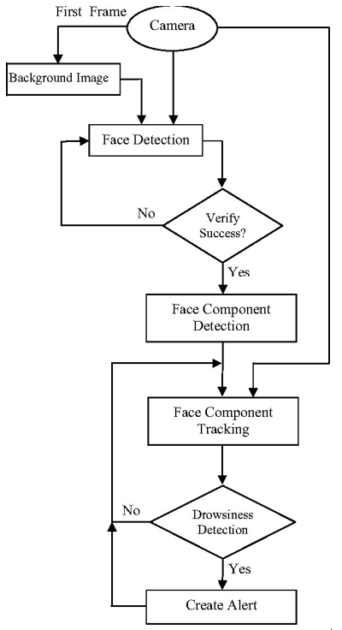
Fig.1 Flow chart for Driver Drowsiness Detection System

- The algorithm uses Dlib library (A toolkit for making real world machine learning and data analysis applications) for the face detection and eye detection.
- Develop program for face detection using OpenCV to determine positive and negative samples.
- If a face is found, we apply facial landmark detection and extract the eye regions.
- Develop program for Eye Detection with the help of Dlib library, Cmake library and numpy library.
- First, the video retrieves an image frame from the camera.
- The algorithm detects the face in the pre-processed image by using facial landmarks produced by Dlib library.
- In the detected face region, the algorithm finds the face landmark.
- The facial landmarks produced by Dlib is an index able list.
- To detect eye region, the correct array slices from the set of face landmarks is detected.
- Using EAR (eye aspect ratio) to determine whether the eyes of the driver are closed or not while driving.
- If the eye aspect ratio indicates that the eyes have been closed for a sufficiently long enough amount of time, we’ll sound an alarm to wake up the driver.
- Set the EAR threshold = 0.25.
- Compute the eye aspect ratio (EAR) of both the eyes.
- Check to see if the eye aspect ratio is below the “blink/closed” eye threshold.
- If it is, we increment COUNTER, the total number of consecutive frames where the person has had their eyes closed.
- Developing an efficient system for the driver drowsiness detection using Arduino to display the suggestions for the driver.
- Using the PySerial module to link Arduino with python. PySerial is a Python API module which is used to read and write serial data to Arduino.
- If the counter is greater than 50, alarm sounds and “ALERT!” is displayed in the LCD.

Eye aspect ratio:
Unlike traditional image processing methods for computing blinks which typically involve some combination of Eye localization threshold to find the whites of the eyes.

Determining if the white region of the eyes disappears for a sufficient period of time which is indicating a blink. The eye aspect ratio is instead a much more elegant solution that involves a very simple calculation based on the ratio of distances between facial landmarks of the eyes. This method for eye blink detection is fast, efficient, and easy to implement.

The eye_aspect_ratio function is used to compute the ratio of distances between the vertical eye landmarks and the distances between the horizontal eye landmarks. The return value of the eye aspect ratio will be approximately constant when the eye is open. The value will then rapid decrease towards zero during a blink. If the eye is closed, the eye aspect ratio will again remain approximately constant, but will be much smaller than the ratio when the eye is open.

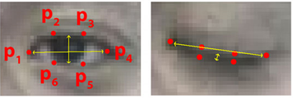

Fig. 2 Left: Visualization of eye landmarks when the eye is open. Right: Eye landmarks when the eye is closed.
We observe, that the eye aspect ratio is constant, then drops quickly to zero, then again increases, indicating a blink. In our drowsiness detector system, we’ll be analyzing the eye aspect ratio to see if the value falls and does not increase back again to constant, this implies that the person has closed their eyes for a sufficient amount of time to sound the alarm.

The formula used for calculation of EAR is as follows:

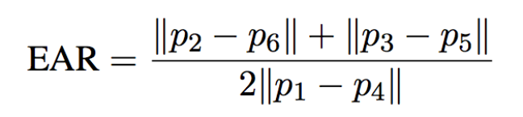
EAR algorithm:
Step 1: Use the Detected Eye region from the algorithm.
Step 2: Compute the Eye Aspect Ratio to determine if the eyes are closed.
Step 3: If EAR satisfies the drowsy condition then move to step 5.
Step 4: If EAR is normal then go to Step 1.
Step 5: Sound Alarm.

LCD display using Liquid Crystal Library in Arduino Uno board:
The LiquidCrystal library allows us to control LCD displays which are compatible with the Hitachi HD44780 driver. The LCDs have a parallel interface, so that the microcontroller has to manipulate several interface pins at a time to control the display. The interface consists of the following pins:

- A register select (RS) pin that controls where in the LCD's memory to which the data is written. We can select either the data register, which holds what goes on the screen, or an instruction register, which is the LCD's controller searches for instructions to perform in future.
- A Read/Write (R/W) pin selects reading mode or writing mode
- An Enable pin enables writing function to the registers.
- 8 data pins (D0 -D7): The states of these pins are the bits that we're writing to a register when we provide an input, or the values we're reading when we display the output.
- There is a display contrast pin (Vo), power supply pins (+5V and Gnd) and LED Backlight (Bklt+ and BKlt-) pins that are used to power the LCD, control the display contrast, switch on and off the LED backlight, respectively.
- The process of controlling the display involves input the data that form the image of what we want to display on the screen, then providing instructions to the instruction register.
- The Hitachi-compatible LCDs can be controlled in two modes: 4-bit or 8-bit. The 4-bit mode requires seven I/O pins from the Arduino, while the 8-bit mode requires 11 pins.
- The alert message is the displaying text on the screen.
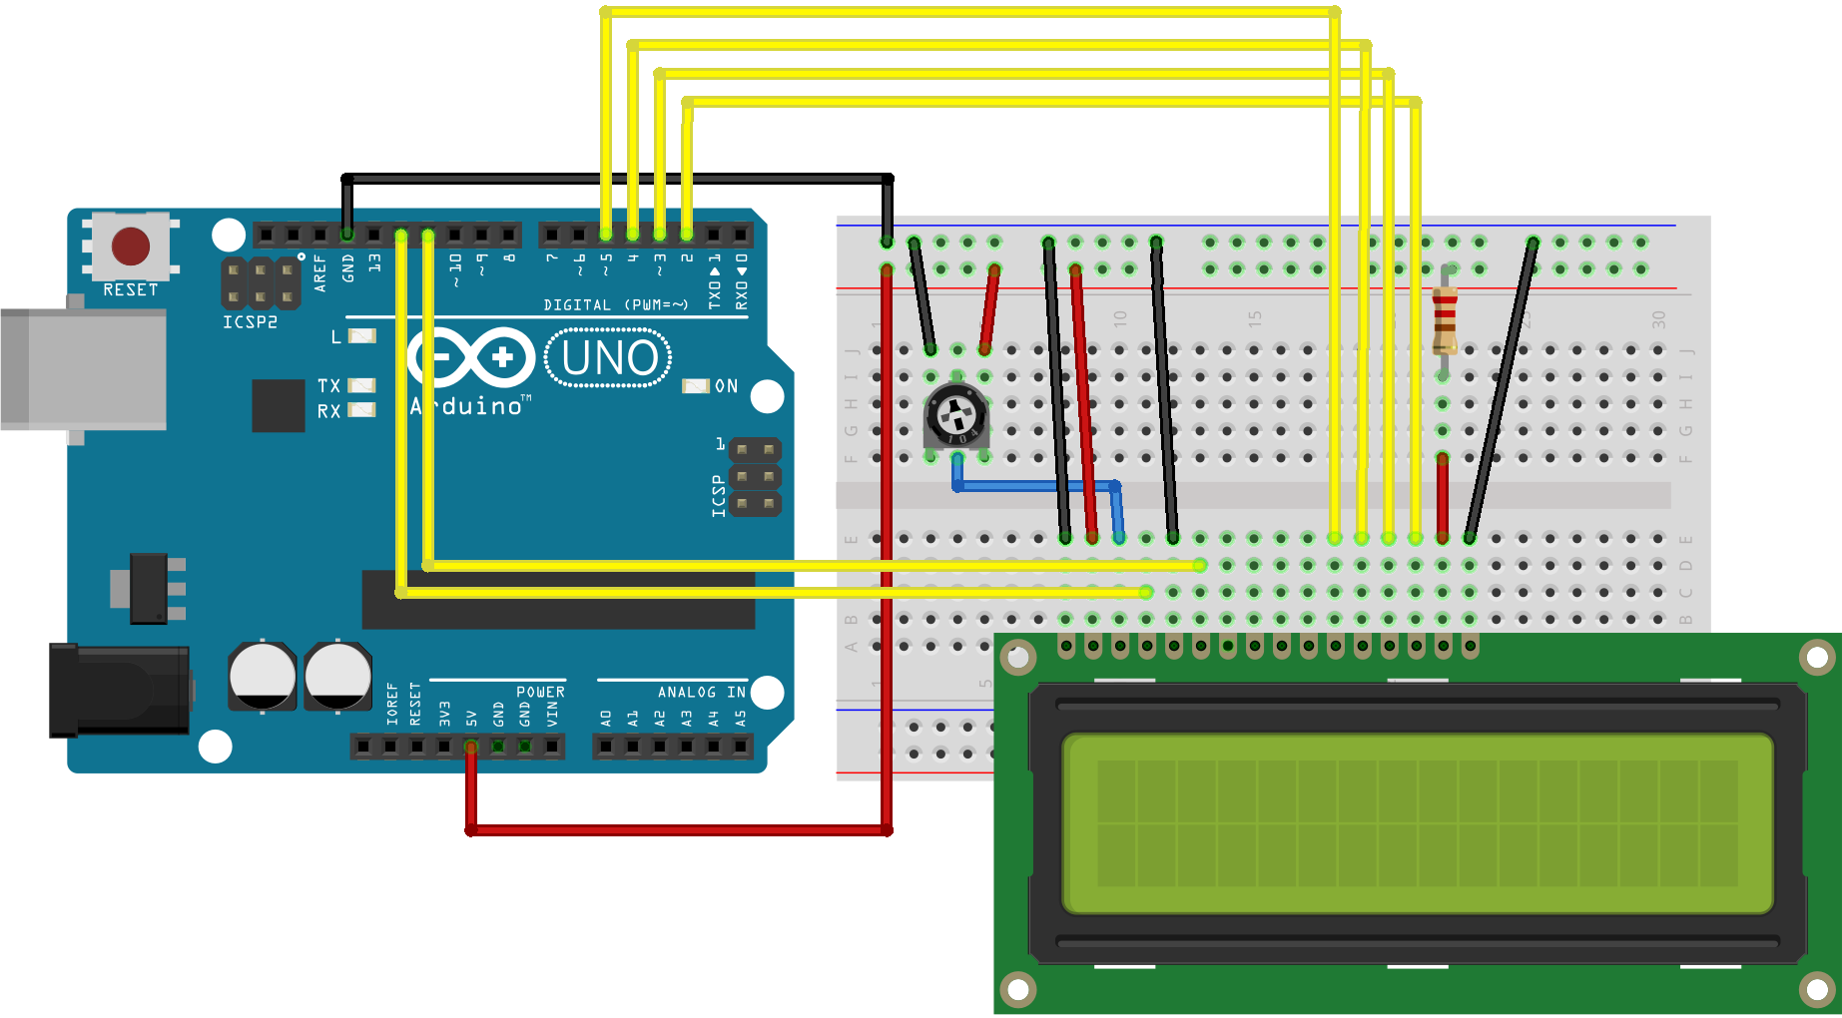
Fig. 3 Circuit diagram for LCD display using Arduino board.
A.Work Done
- Develop program for face detection using OpenCV to determine positive and negative samples.
- If a face is found, we apply facial landmark detection and extract the eye regions.
- Develop program for Eye Detection with the help of Dlib library, Cmake library and numpy library.
- Using EAR (eye aspect ratio) to determine whether the eyes of the driver are closed or not while driving.
- If the eye aspect ratio indicates that the eyes have been closed for a sufficiently long enough amount of time, we’ll sound an alarm to wake up the driver.
- EAR threshold = 0.25.
- Developing an efficient system for the driver drowsiness detection using Arduino to display the alert message so the drivers participating in the traffic will slow down or stop their vehicles.
- Using the PySerial module to link Arduino with python. PySerial is a Python API module which is used to read and write serial data to Arduino.
- Testing and implementation of System by measuring the accuracy and robustness of the system.

V. RESULTS AND ANALYSIS

VI. CONCLUSION

References
The template will number citations consecutively within brackets [1]. The sentence punctuation follows the bracket [2]. Refer simply to the reference number, as in [3]—do not use “Ref. [3]” or “reference [3]” except at the beginning of a sentence: “Reference [3] was the first ...”
Number footnotes separately in superscripts. Place the actual footnote at the bottom of the column in which it was cited. Do not put footnotes in the abstract or reference list. Use letters for table footnotes.
Unless there are six authors or more give all authors’ names; do not use “et al.”. Papers that have not been published, even if they have been submitted for publication, should be cited as “unpublished” [4]. Papers that have been accepted for publication should be cited as “in press” [5]. Capitalize only the first word in a paper title, except for proper nouns and element symbols.
For papers published in translation journals, please give the English citation first, followed by the original foreign-language citation [6].

- G. Eason, B. Noble, and I. N. Sneddon, “On certain integrals of Lipschitz-Hankel type involving products of Bessel functions,” Phil. Trans. Roy. Soc. London, vol. A247, pp. 529–551, April 1955. (references)
- J. Clerk Maxwell, A Treatise on Electricity and Magnetism, 3rd ed., vol. 2. Oxford: Clarendon, 1892, pp.68–73.
- I. S. Jacobs and C. P. Bean, “Fine particles, thin films and exchange anisotropy,” in Magnetism, vol. III, G. T. Rado and H. Suhl, Eds. New York: Academic, 1963, pp. 271–350.
- K. Elissa, “Title of paper if known,” unpublished.
- R. Nicole, “Title of paper with only first word capitalized,” J. Name Stand. Abbrev., in press.
- Y. Yorozu, M. Hirano, K. Oka, and Y. Tagawa, “Electron spectroscopy studies on magneto-optical media and plastic substrate interface,” IEEE Transl. J. Magn. Japan, vol. 2, pp. 740–741, August 1987 [Digests 9th Annual Conf. Magnetics Japan, p. 301, 1982].
- M. Young, The Technical Writer’s Handbook. Mill Valley, CA: University Science, 1989.

IEEE conference templates contain guidance text for composing and formatting conference papers. Please ensure that all template text is removed from your conference paper prior to submission to the conference. Failure to remove template text from your paper may result in your paper not being published.

